Group Members:
- Ali Asghar (2059)
- Shahad Bangash (1980)
- Suleman Shah (1983)

SHOW TABLES Command:
show tables command display the list of all the tables in our databases as shown in figure 1-1
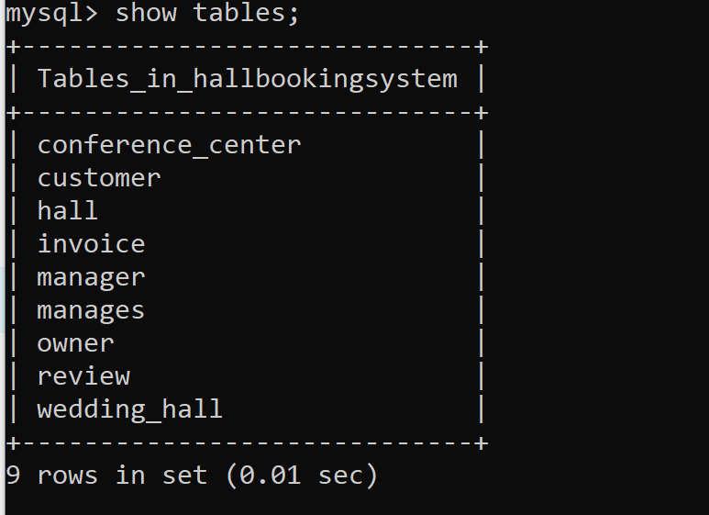
Figure 1-1, All tables in Hall Booking System Database

DESCRIBE TABLE Commands:
Following are the describe commands for all the tables present in the database.
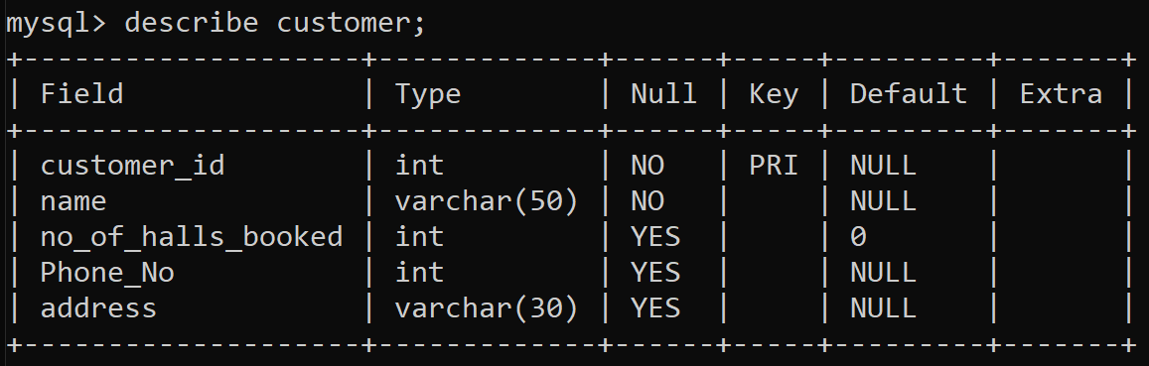
Figure 2-1, Metadata of customer table in Hall Booking System Database

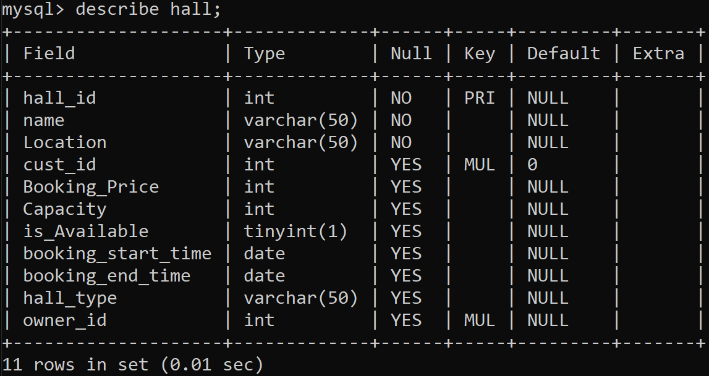
Figure 2-2, Metadata of hall table in Hall Booking System Database

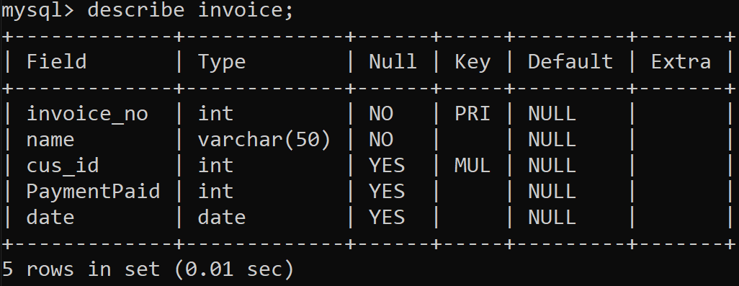
Figure 2-3, Metadata of invoice table in Hall Booking System Database

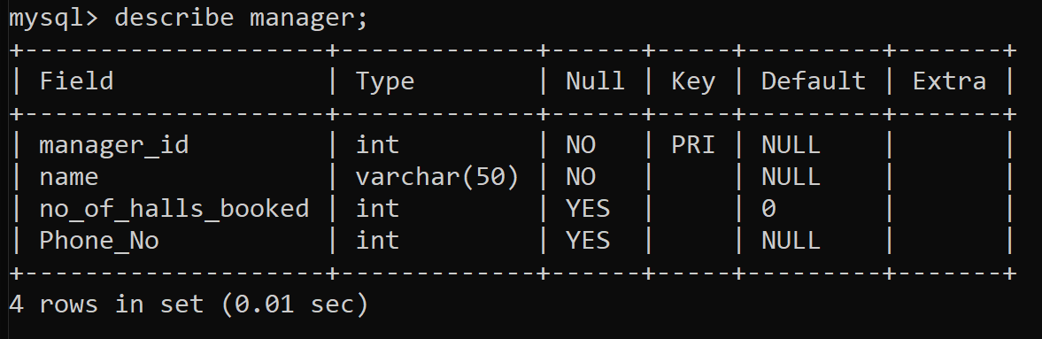
Figure 2-4, Metadata of manager table in Hall Booking System Database

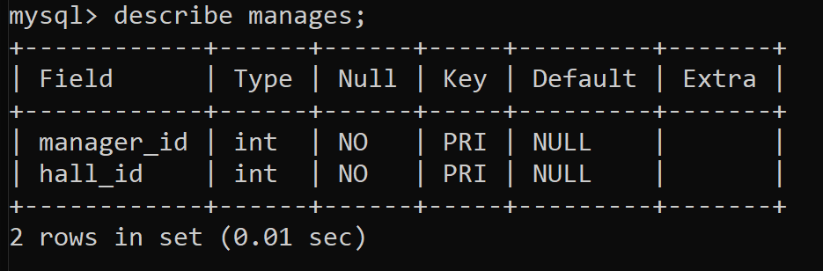
Figure 2-5, Metadata of manages table in Hall Booking System Database
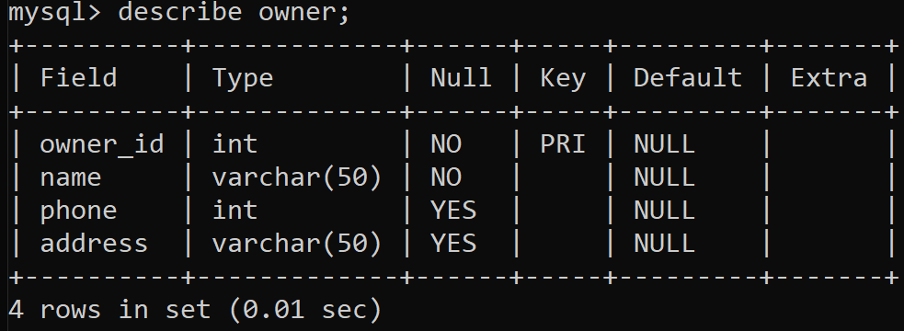
Figure 2-6, Metadata of owner table in Hall Booking System Database

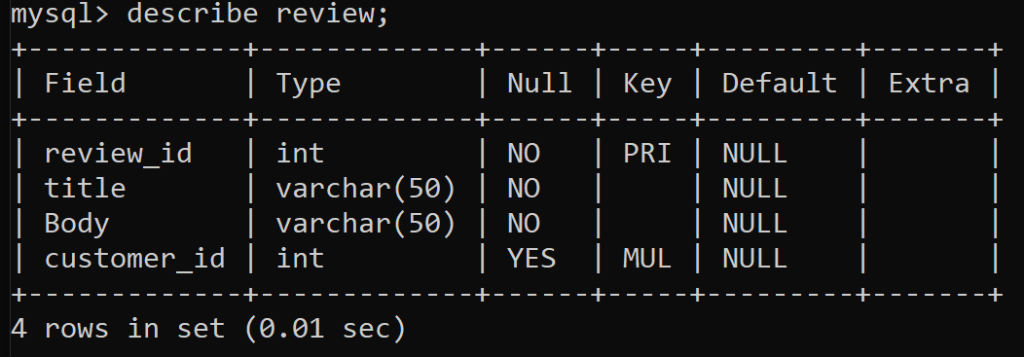
Figure 2-7, Metadata of review table in Hall Booking System Database

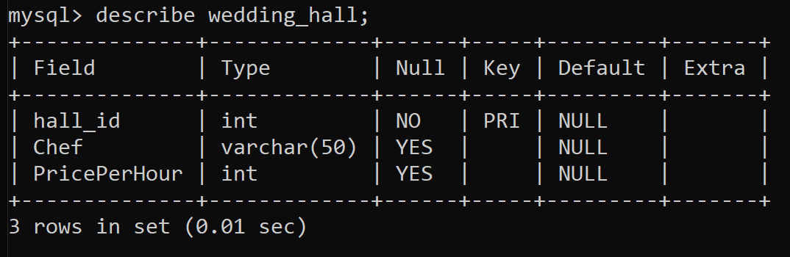
Figure 2-8, Metadata of wedding_hall table in Hall Booking System Database

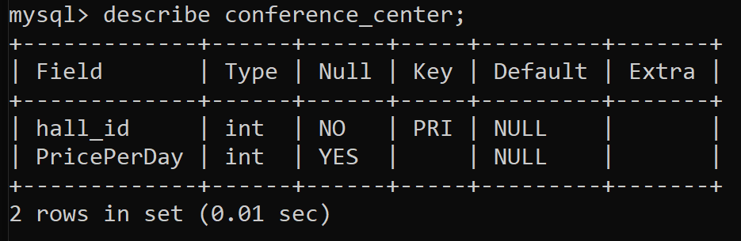
Figure 2-9, Metadata of conference_center table in Hall Booking System Database

SHOW CREATE TABLE Command:
Following are the create table commands for all the tables present in the database.

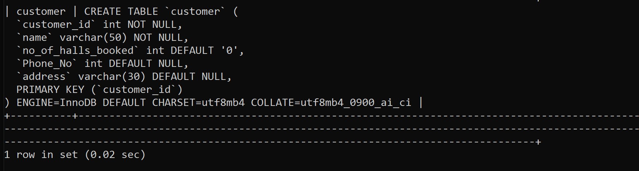
Figure 3-1, create table command for customer table in Hall Booking System Database

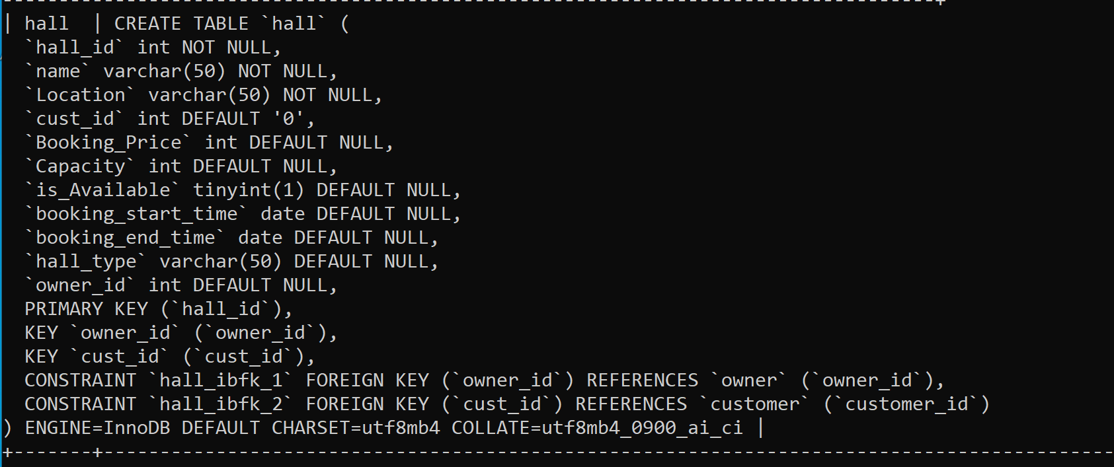
Figure 3-2, create table command for hall table in Hall Booking System Database

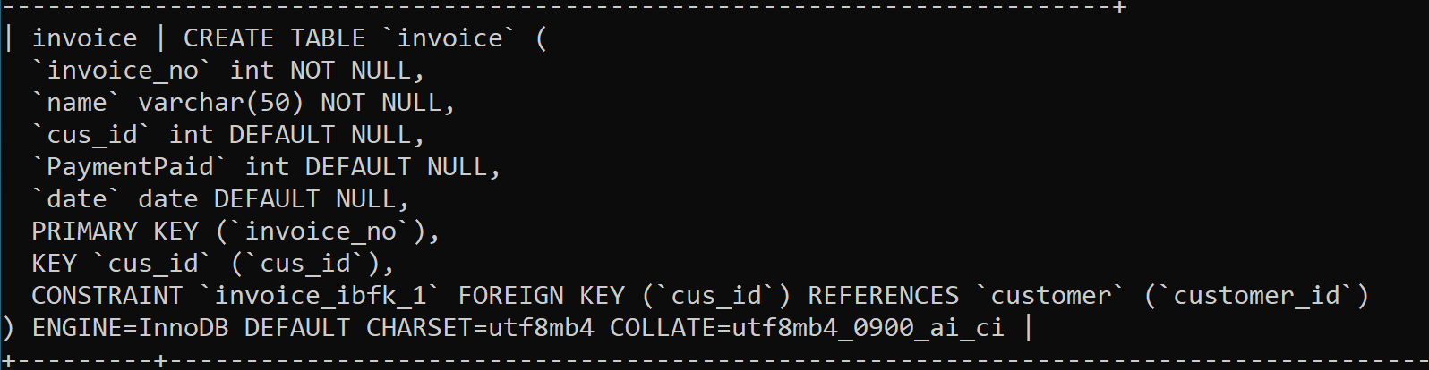
Figure 3-3, create table command for invoice table in Hall Booking System Database

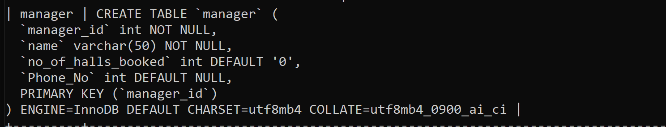
Figure 3-4, create table command for manager table in Hall Booking System Database

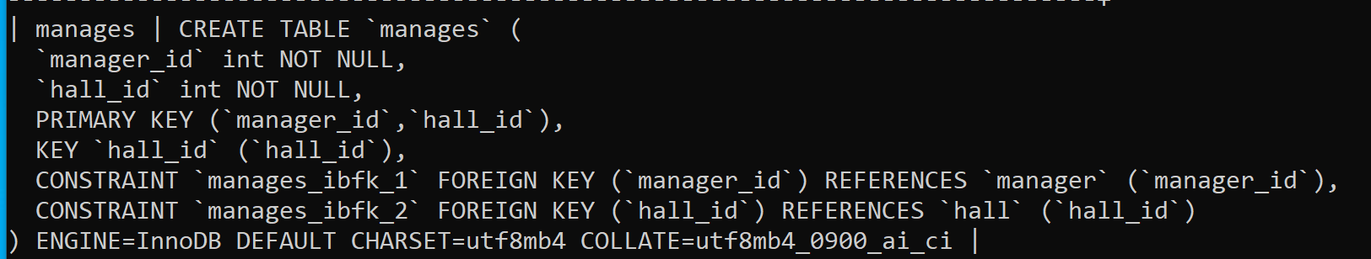
Figure 3-5, create table command for manages table in Hall Booking System Database

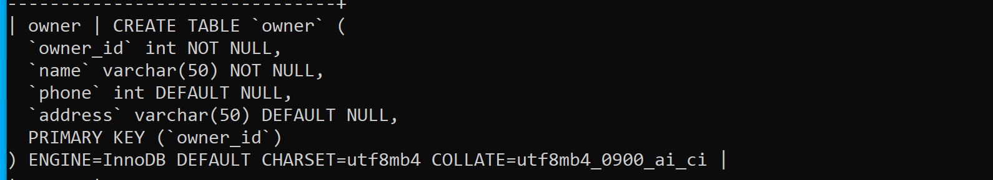
Figure 3-6, create table command for owner table in Hall Booking System Database

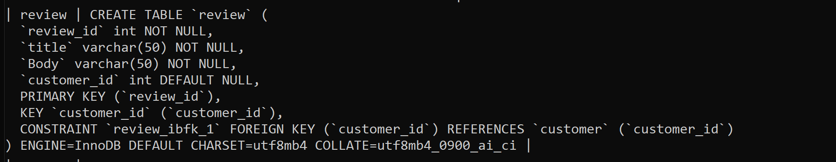
Figure 3-7, create table command for review table in Hall Booking System Database

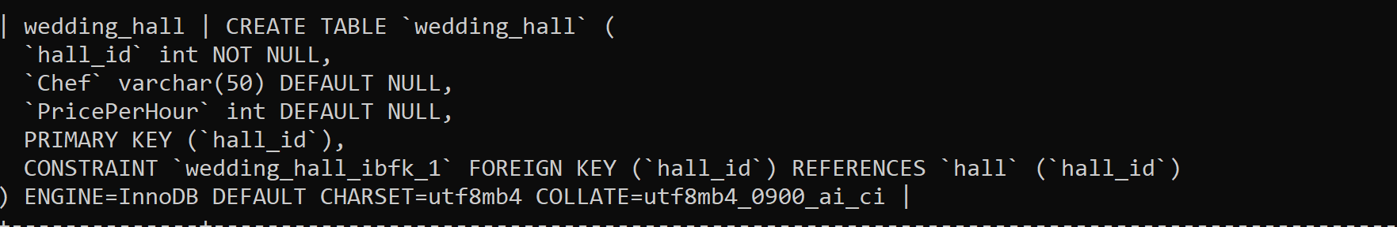
Figure 3-8, create table command for wedding_hall table in Hall Booking System Database

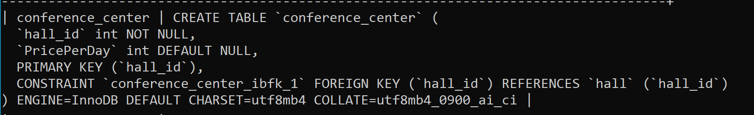
Figure 3-9, create table command for conference_center table in Hall Booking System Database

SELECT * FROM TABLE Command:
Following are the select * from table commands for all the tables present in the database.

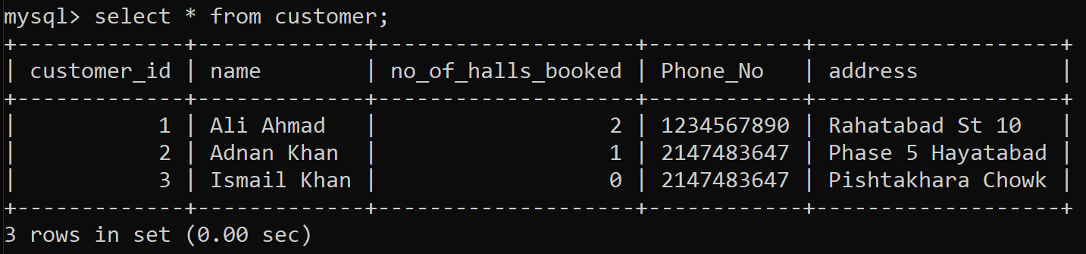
Figure 4-1 select * command for customer table in Hall Booking System Database

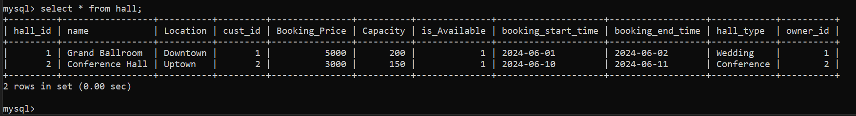
Figure 4-2 select * command for hall table in Hall Booking System Database

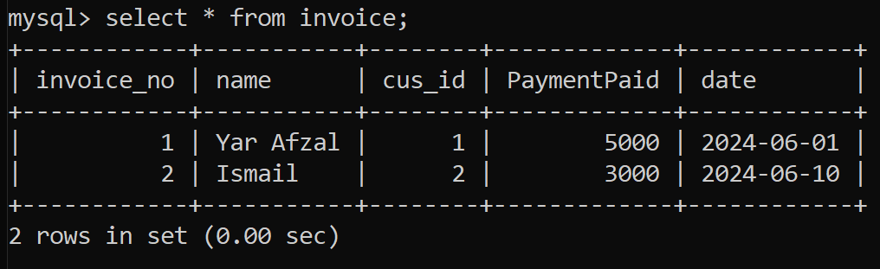
Figure 4-3 select * command for invoice table in Hall Booking System Database

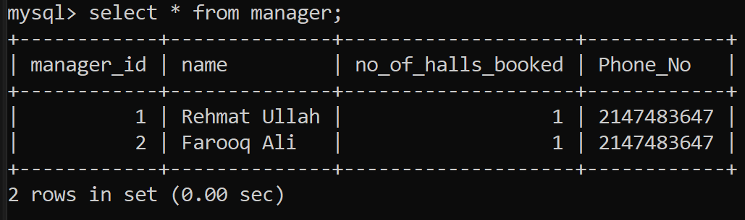
Figure 4-4 select * command for manager table in Hall Booking System Database

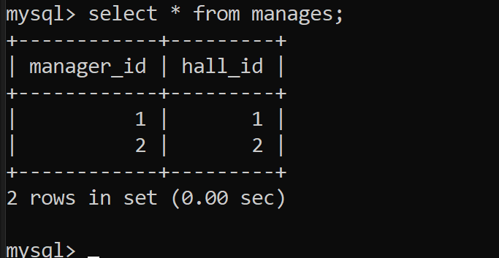
Figure 4-5 select * command for manages table in Hall Booking System Database

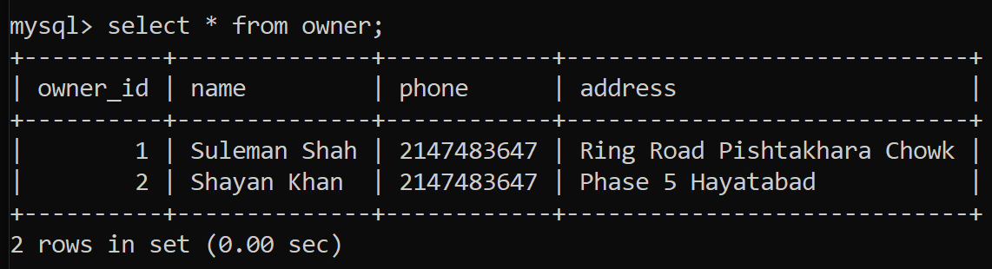
Figure 4-6 select * command for owner table in Hall Booking System Database

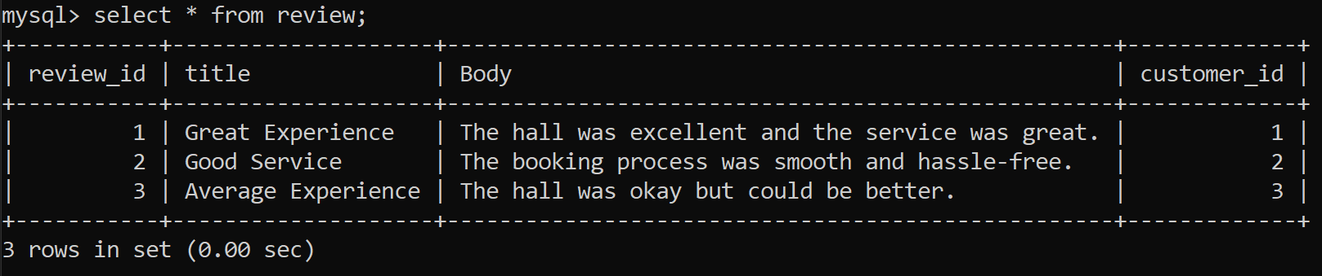
Figure 4-7 select * command for review table in Hall Booking System Database

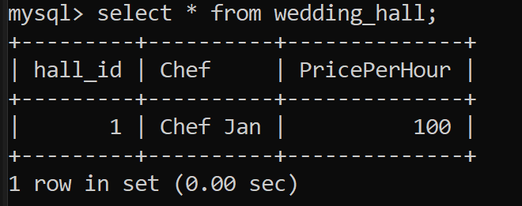
Figure 4-8 select * command for wedding_hall table in Hall Booking System Database

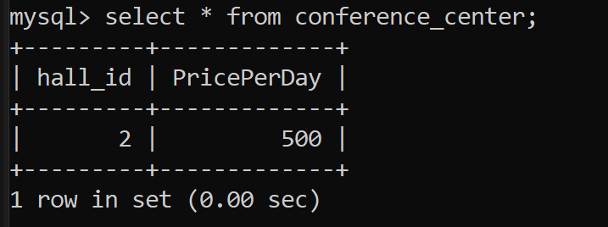
Figure 4-9 select * command for conference_center table in Hall Booking System Database

SELECT * FROM TABLE Command with Variations:

Retrieve All Customers and Their Bookings
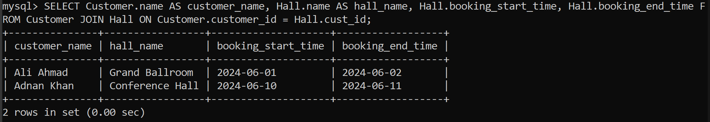
Figure 5-1, Retrieve All Customers and Their Bookings in Hall Booking System Database

Find All Halls Managed by a Specific Manager
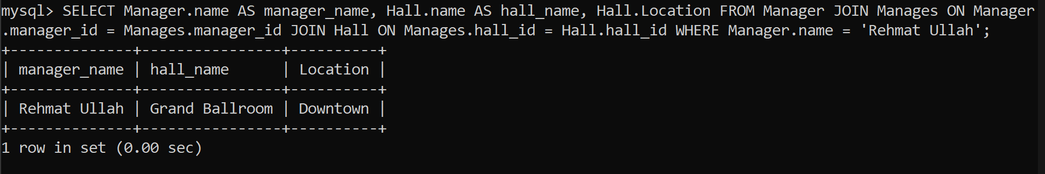
Figure 5-2, Find All Halls Managed by a Specific Manager in Hall Booking System Database

List all reviews submitted by Customer
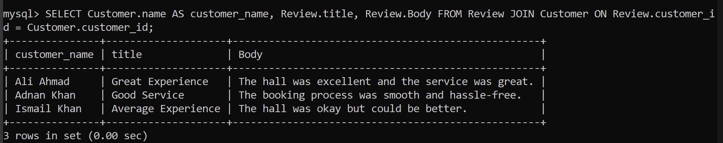
Figure 5-3, List All reviews submitted by Customer in Hall Booking System Database

Retrieve All Invoices for a Specific Customer
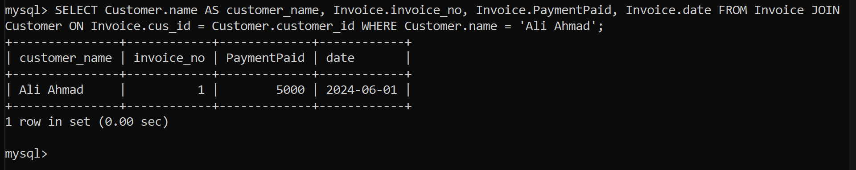
Figure 5-4, Retrieve All Invoices for a Specific Customer in Hall Booking System Database

Retrieve List of all available halls
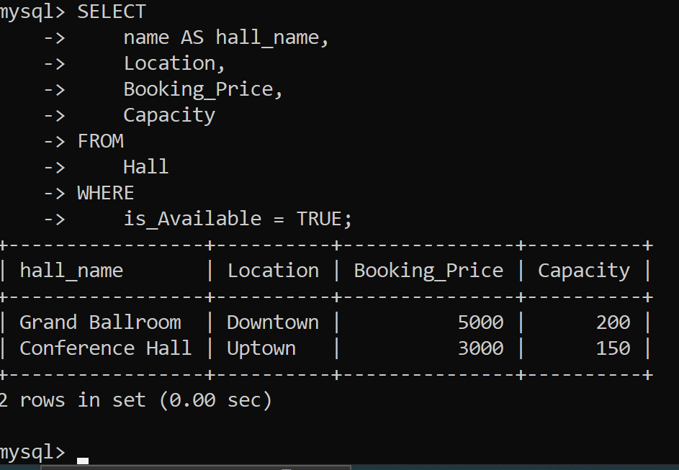
Figure 5-5, Retrieve List of all available halls in Hall Booking System Database

